**Date: November 3, 2016**

**To: Jason Learned (FDOT District 5)**

**From: Tim Palermo**

**RE: DRAFT Updated Special Attractions for CFRPM 6.1**

Introduction

Given their dated, pre-recession provenance, limited documentation, and suspiciously illogical values, the special attraction production variables contained in CFRPM were updated for release 6.1. These values are used by the model to produce person trips associated with Central Florida’s exceptional themed attractions, convention center, airport, cruise port, and water parks. These person trips are associated with substantially higher auto occupancies during the mode choice step later in the model stream. The original CFRPM production variables, which did not change for any of the model’s future year scenarios, are shown on **Table 1.**



Theme and Water Park Productions

The 2010 and 2015 editions of the annually-published *Global Attractions Attendance Report* were used to update the level of theme park productions contained the CFRPM. **Table 2** below shows the amount of theme and water park related productions for 2010 and 2015. The production variables were calculated by dividing reported annual attendance by an annualization factor and multiplying by two in order to account for each trip end associated with park attendance.



It was determined that, given central Florida’s long, consistent history of escalating theme park attendance, it was not realistic to keep these values static across future scenario years as was done previously. Therefore, each theme park was grown using a compound annual growth rate (CAGR) of 1.16 % which was derived from linearly-extrapolated historic (1991-2015) growth in annual Magic Kingdom attendance. Waterpark attendance remained constant for future years. Wet-n-Wild attendance was added to Universal Studios to account for its closing in summer 2016 and the subsequent opening of Volcano Bay by summer 2017.

Orlando International Airport

Forecast airport passenger enplanements and deplanements were obtained from passenger forecasts developed during the course of SunRail Phase 3 model calibration and were based on GOAA’s June *2015 Traffic Summary Report* and grown for future years using a CAGR of 3.8%; consistent with official GOAA passenger forecasts (**Figure 1**). Forecast airport passengers were allocated between the north and south terminals based upon the portion of total gates contained in each as shown in **Table 3**.



**Figure 1[1]**

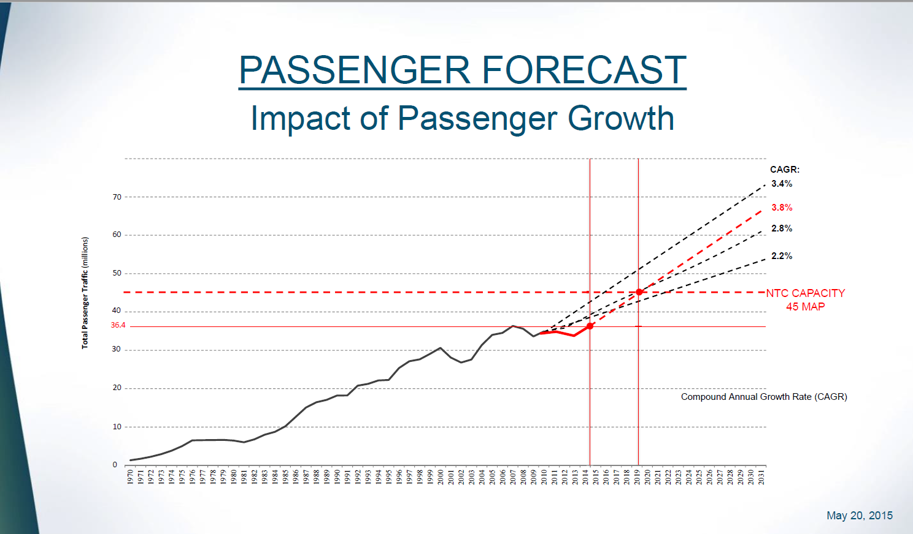

1. Source: <http://www.orlandoairports.net/statistics/monthly/trfc201506.pdf>

   Visitor, Resident and External Airport Productions

   The 2015 Passenger Survey was conducted by HNTB for the period between July 6 and July 17, 2015 as used along with zip code matching was performed to determine the percentage of resident and visitor passengers that originated within the CFRPM study area. **Tables 4** **and** **5** summarize the results of this effort.

   

   

   Orange County Convention Center

   Five years of monthly attendance data was used in an attempt to normalize the high level of variability associated with convention center activities. Upon review of this data, it was determined that normalization could be accomplished by taking the average of the top four consecutive months of the most recent year which complete data was available (2015) which yielded an average daily attendance of 12,602 which was allocated in proportion to the amount of total square footage at the North/South and West convention facilities. Future years were increased using the same CAGR (3.8%) as for OIA.

   Port Canaveral

   The original CFRPM daily Port Canaveral special attraction productions were used as the basis for future years which assumed three additional cruise ship berths on-line by 2025. Three additional berths account for Port Canaveral receiving approximately one-third of total forecast cruise passenger growth to 2040.

   Final Updated CFRPM 6.1 Special Attraction Productions

   FDOT approved the CFRPM special attraction productions and supporting assumptions on October 28, 2016 which are contained in **Table 6**. Supporting data and pertinent background materials are attached.

   